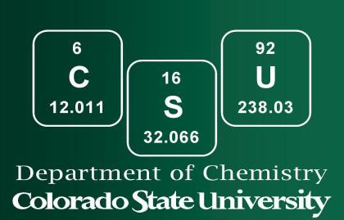

Chemistry Department

Accelerated Master’s Program Application
The Accelerated Degree Program partners an undergraduate and graduate degree to create a
bachelor’s/master’s program. The Accelerated Degree Program is established to encourage students with strong scholarly and/or research interests to continue their education at the master’s level. Students pursuing a Bachelor of Science degree in Chemistry are guaranteed contingent admission to the MS program by meeting the requirements detailed by the department’s agreement with the Graduate School. Final admission to the MS program is conferred when the students meet the minimum Accelerated Program and Graduate School admissions criteria upon completion of their bachelor’s degree. Students must complete the Graduate Admissions Application.

Applications are accepted and reviewed each semester. Students should use these preferred due dates:
- Spring semester: April 1st
- Fall semester: November 1st

APPLICATION FORM

Student Information:
Student’s Name: Email Address:

CSU ID #:
Phone:

Current Standing as Chemistry Major
Year of study:
Junior
Senior

Credit hours earned as of today (include your current semester course load) Credit hours earned, including this semester’s course load (please select all that apply) General Chemistry
CHEM 111 General Chemistry I
CHEM 112 General Chemistry I Laboratory
CHEM 113 General Chemistry II
CHEM 114 General Chemistry II Laboratory

Organic Chemistry
CHEM 345 Organic Chemistry I
CHEM 346 Organic Chemistry II
– OR –
CHEM 341 Modern Organic Chemistry I
CHEM 343 Modern Organic Chemistry II
CHEM 344 Modern Organic Chemistry Lab

Analytical and Physical Chemistry
CHEM 335 Introduction to Analytical Chemistry
CHEM 334 Quantitative Analysis Laboratory
CHEM 474 Physical Chemistry I
CHEM 475 Physical Chemistry Laboratory I

Science and Mathematics
MATH 160 Calculus for Physical Scientists
MATH 161 Calculus for Physical Scientists II
MATH 271 Applied Mathematics for Chemists I
PH 141 Physics for Scientists and Engineers I
PH 142 Physics for Scientists and Engineers II Cumulative GPA
Applicants must submit the following application materials by the deadline to be considered for the program:

Letters of Recommendation:

Submit 2 email addresses for letters of support. A minimum of one letter must come from a Chemistry faculty member.

Email address 1:

Email address 2:

Please contact your references ahead of time to be sure they are willing to respond to our request for a recommendation. Ask them to discuss your leadership, academic standards, and skills as they pertain to your primary interest area. Once you submit your application, your references will be contacted and asked to submit a recommendation form electronically. Since your references’ recommendations will come directly to the Chemistry Department electronically, there is no need for a paper copy of the recommendation.

Statement of Purpose (as an attachment to the application form)

Statement of purpose should be no more than one page in length (500 words, single spaced). The statement should include your goals and background as it relates to the field of Chemistry, including any past research history, interests, and reasons for pursuing a graduate degree in Chemistry. The statement of purpose will be evaluated for conciseness, scientific research interests, leadership skills,

and mastery of the English language. The statement should also include your research interest areas. Following admission, you will need to select a research mentor. A current list of advisors can be found on the department website (www.chem.colostate.edu).

