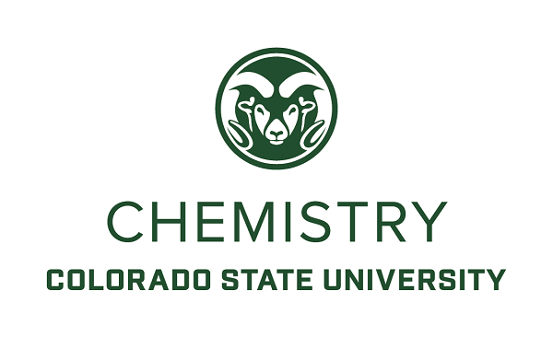

TEACHING-FOCUSED FACULTY POSITION IN CHEMISTRY

The Department of Chemistry at Colorado State University, located in Fort Collins, CO, seeks to hire at least one non-tenure track Assistant Professor with interest and experience in large lecture course instruction, for continuing 9-month appointments. Exceptional candidates with teaching experience in general chemistry are encouraged to apply.

We aim to fill this position at the Assistant Professor level. Candidates must hold a Ph.D. or equivalent degree and be capable of outstanding teaching, instructional scholarship, and service. Experience teaching undergraduate general chemistry courses is highly desirable. Complete applications must include a cover letter, detailed CV, a teaching experience highlight, a statement of commitment to diversity and inclusion, and the names of at least three references. In your cover letter, please address your willingness to work in a team environment, and any experiences doing so. For the “teaching experience highlight” please upload a 1-page highlight describing an experience in teaching general chemistry that best describes you as an educator. Representative examples include a description of your favorite innovative teaching practice, curriculum development project, a particularly challenging assignment you executed successfully, or an especially inspiring student success story. For the “statement of commitment to diversity and inclusion” please upload a 1-page personal statement describing your contribution(s) and commitment to diversity and inclusion, which will help us identify candidates who have the professional skills, experience, and/or willingness to engage in activities that advance our campus diversity and equity goals. Contributions can take a variety of forms including your teaching, mentorship, or outreach experiences and efforts. The College of Natural Sciences’ efforts in diversity, equity and inclusion are described here: https://www.natsci.colostate.edu/diversity-inclusion/. Letters of reference will be requested immediately upon submission of an application. Please inform your references that letters should be submitted by December 4, 2022, to ensure full consideration.

For more information or to apply see https://jobs.colostate.edu/postings/113859. Questions regarding the searches should be directed to Chair, Faculty Search Committee, CHEM_search@mail.colostate.edu. Applications will be accepted until the positions are filled; applications completed by 11:59 PM (MT) on November 27, 2022, will receive full consideration. Files of semifinalists (including reference letters) will be available to all Chemistry Department faculty. CSU is an EO/EA/AA employer. Colorado State University conducts background checks on all final candidates.

